

**SECP1513-02 TECHNOLOGY AND INFORMATION SYSTEM**

**DESIGN THINKING PROJECT REPORT**

**TITLE: ENERGY USAGE AND SUSTAINABILITY**

**GROUP 4: SYNTECH**

**LECTURER: DR. ARYATI BINTI BAKRI**

Group Members:

|  |  |  |
| --- | --- | --- |
| SHASYA SHAFIEQAH BINTI SHAHARUDDIN  A25CS0350 | YONG SEE EN  A25CS0168 | BALQIS BATRISYA BINTI JALALUDDIN  A25CS0196 |

CONTENTS

1.0 INTRODUCTION 3

1.1 Background 3

1.2 Purpose 3

2.0 DETAIL STEPS 4

3.0 DETAIL DESCRIPTION 5

3.1 Problem 5

3.2 Solution 5

3.3 Team Working 6

4.0 DESIGN THINKING EVIDENCE 7

4.1 Sample Work 7

4.2 Record for each phase 9

4.2.1 Empathy 9

4.2.2 Define 12

4.2.3 Ideate 13

4.2.4 Prototype 14

4.2.5 Test 17

5.0 REFLECTIONS 18

6.0 TASK DISTRIBUTION 21

7.0 CONCLUSION 21

8.0 REFERENCE 22

9.0 VIDEO 22

10.0 APPENDIX 23

# 1.0 INTRODUCTION

## 1.1 Background

According to official academic information that publish by University Teknologi Malaysia (UTM), it stated that UTM has twelve (12) of Faculties. (Universiti Teknologi Malaysia, n.d.) Faculties offer a variety of learning spaces, such as lecture halls, tutorial rooms, laboratories, and seminar room, which support students’ daily academic activities. As a result, classrooms play a major role in overall campus energy usage due to the continuous operation of lighting, air-conditioning, audio and visual equipment along with other electric appliances. While it is impossible to eliminate this energy use entirely as, it can be reduced. To solve the problem, a thermal imaging sensor device called “ThermiQ” was decided to be developed by our team, designed to assist UTM staff especially UTM technical staff in saving energy.

## 1.2 Purpose

The purpose of this project is to identify how energy is currently being used in classrooms on campus since energy wastage is a common problem nowadays. This project is aiming to design a system that can automate the control of lights, air-conditioning, and other equipment based on room occupancy so that the electricity use and energy wastage can be reduce. Therefore, thermal imaging sensor is created to accurately detect the real human presence. On top of that, this project is supporting university's sustainability initiatives and applying the data-driven method to tackle the real problems. It will also enhance the energy efficiency without disrupting daily learning activities.

# 2.0 DETAIL STEPS

|  |  |
| --- | --- |
| Empathize | A survey was carried out to collect data for understanding the issues faced by students and their opinions on the features through google form. At the same time, a face-to-face interview with a UTM staff, Mr. Mohd Idzham Iqbal was also conducted to explore deeply the problems occurring in the UTM campus. |
| Define | All the data collected from the empathize stage, which consists of a total of 35 responses were analysed during our discussion. From the survey, the existing issues faced by students and their desired additional features were finally understood. One of the challenges is the electrical equipment continuously operating even after the class has ended, where it leads to higher energy consumption and energy waste. |
| Ideate | Five (5) potential solutions have been suggested to address the identified problem, including thermal sensor, energy monitoring application, smart timetable, motion sensor auto shut off, and overload protection. Thermal sensor is selected as the most suitable solution due to the ability to detect human presence accurately. Another solution being chosen is matric card reader, detecting the presence of matric card to turn on the individual electrical equipment such as desktops. |
| Prototype | In this phase, a prototype was created by designing the interface and mock-up using Canva. The students’ desired features were incorporated into the prototype to better address their needs and expectations. |
| Test | The prototype was tested to make sure the product can function smoothly. The first test was conducted by the team members to detect any errors that might affect the functionality, accuracy, or usability of the prototype. After that, two (2) students were invited to use the prototype and provide feedback on its usability, clarity, and effectiveness in promoting energy-saving behaviour. In this phase, the product was improved based on the students’ feedback. |

# 3.0 DETAIL DESCRIPTION

## 3.1 Problem

There are three (3) problems identified in this project, which are air-conditioning and lights remain switched on in empty classrooms, individual electrical equipment is not properly shut down after being used, and all electricity is turned on even there are only a few students in a classroom. As a result, a large amount of energy is used unnecessarily.

Based on data collection, although energy saving is practiced by most of the students, there are still many of them who did not care much about energy usage when leaving the classroom. This is mainly because they are assuming others to do it instead of themselves, and if this mindset keeps going, the problem will never be solved. Energy wastage also happened because they are in a hurry and forget to do so.

## 3.2 Solution

Two (2) solution had been proposed to create a device that can help students and staff in saving energy without thinking about switch off the lights and other equipment manually. Based on the respondents’ choices, majority choses motion sensor auto shut off as the most useful features. After discussion, thermal imaging sensor was chosen as a final solution because motion sensor only responds to physical movement.

Thermal imaging sensor or “ThermiQ” is personally created to detect human temperature, where it can show whether the room is occupied or not. “ThermiQ” can also identify the exact area in the room that is being occupied by students and lecturer. This allows the device to manage energy usage more efficiently based on the real occupancy.

Another solution that had been proposed is matric card reader, where students need to put their matric card at the provided place in order to use the individual electrical equipment. Without being able to do so, the equipment cannot be used, at the same time students will become more alert and realize that the matric card is important in their daily life as a student. Therefore, the classrooms facilities can be controlled more effectively to reduce energy consumption.

## 3.3 Team Working

This project was completed by dividing roles and responsibilities among team members. Communication was mainly carried out through WhatsApp and meetings were held to discuss progress, brainstorm ideas and share the ideas with one another. Each member has different ideas, but discussion is made to decide which idea is the most suitable or combine the ideas to produce a good result. On top of that, strong team dynamics enable individual members to divide complex projects into manageable tasks (Team Asana , 2025). This project helped a lot in building a great teamwork.

# 4.0 DESIGN THINKING EVIDENCE

## 4.1 Sample Work

|  |  |
| --- | --- |
| **Empathy** |  |
| **Define** |  |
| **Ideate** |  |
| **Prototype** |  |
| **Testing** |  |

## 4.2 Record for each phase

### 4.2.1 Empathy

An interview session was conducted with staff A, a UTM technical staff at Faculty of Computing. His view on energy wastage as well as his role as technical staff in managing and controlling energy use was obtained from this interview. A student was also interviewed to gather her opinion on energy wastage. Besides that, a survey was conducted to collect and gather not only the issues faced by students but also their suggested additional functions and features in campus energy by using google form.

**User Research Summary**

* Target users: UTM students and UTM staffs
* Methods: Face-to-face interviews and Google Form
* Key findings:
* Do not regularly monitor energy usage
* Lack tools to track consumption
* Electrical appliances remain on in empty classrooms

**Composite character**

**Age:** 19

**Background:** UTM student

**Goals:** - To practice sustainable energy usage

- To reduce environmental impact and carbon footprints

-To avoid wasting electricity when electrical appliances are not in use

**Problems:** -Packed timetable causes users to rush between different classrooms

- Forget to switch off all the electrical appliances when leaving classrooms

- Assume others will switch off the equipment

- Feel it is not their responsibility

**Behaviours:** - Rarely switch off electrical appliances after leaving classrooms

- Hesitation to switch off equipment due to unclear responsibility

**Interview questions**

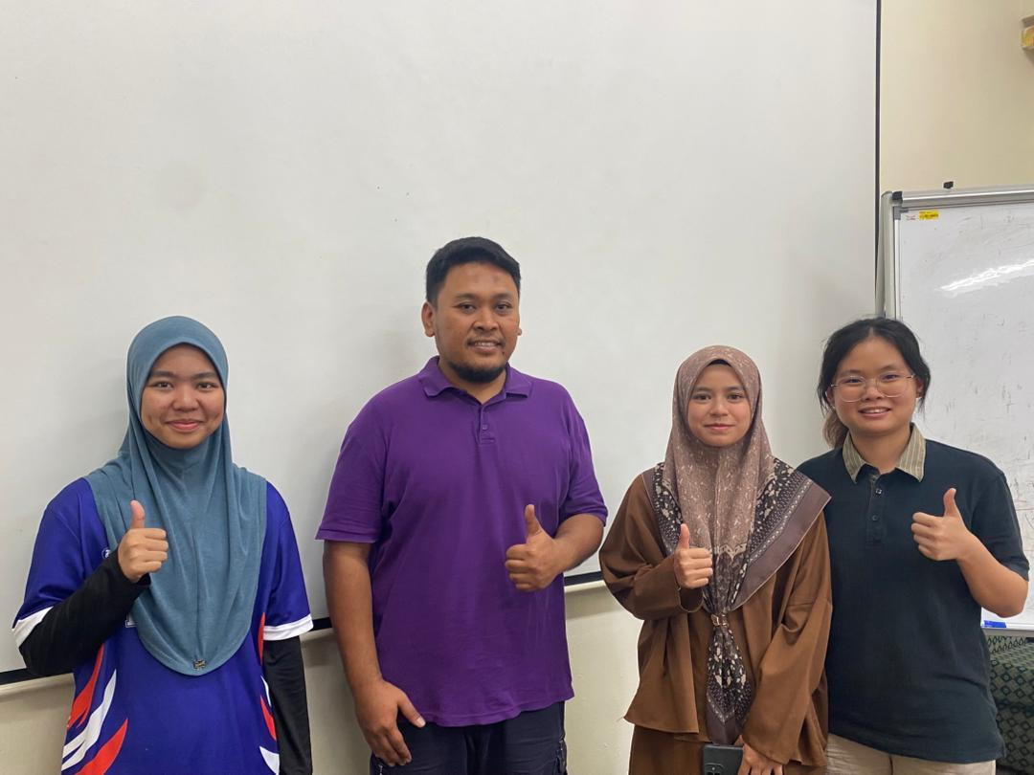

Figure 1: Interview session with staff A

1. What common energy wastage issues staff encounter in classroom?
2. Is there a schedule or routine for checking classrooms to ensure equipment is switched off?

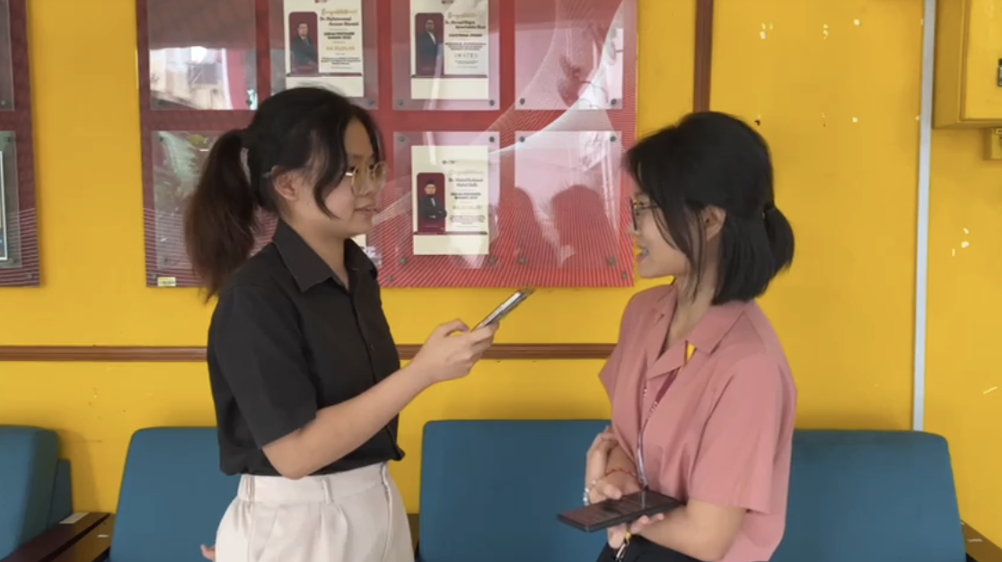

Figure 2: Interview session with student from Faculty of Computing

1. Does seeing energy waste affect your perception of the university’s sustainability efforts? And why?
2. What are the most common energy wastage issues you observe on campus?

|  |  |
| --- | --- |
|  |  |
|  |  |

Figure 3: List of questions for Google Form

Figure 3 shows the questions of four (4) part, which are part B (Awareness of Energy Usage), part C (Current Behaviour), part D (Problems Faced), and part E (Smart Energy Solution – Ideation Support), where students need to answer when they open the link of the survey.

### 4.2.2 Define

In this phase, all the data that obtained from the interview sessions and Google Form survey was collected, which consists of a total of 35 responses. The issues they faced were clearly identified and understood, which allowed a more effective solution to be designed that addresses the problems and fulfils their needs. After analysing the data and opinions obtained, the students struggle was understood, where they need to manage energy usage in lecture halls, tutorial rooms, laboratories, and seminar room due to lack of awareness of energy sustainability practices, have a packed timetable and often feels it is not their responsibility to switch off shared equipment. This leads to energy wastage and increase in carbon footprints.

**4.2.2.1 Respondent’s Profile**

Figure 4 shows the respondent’s profile based on gender, age, year, and faculty based on the data obtained for Part A (Demographic Profile) of the survey.

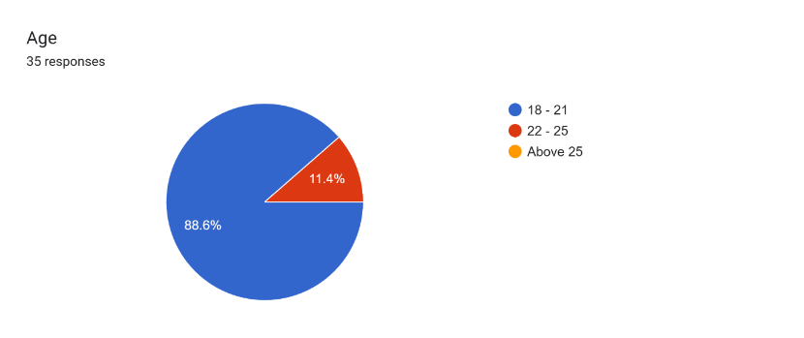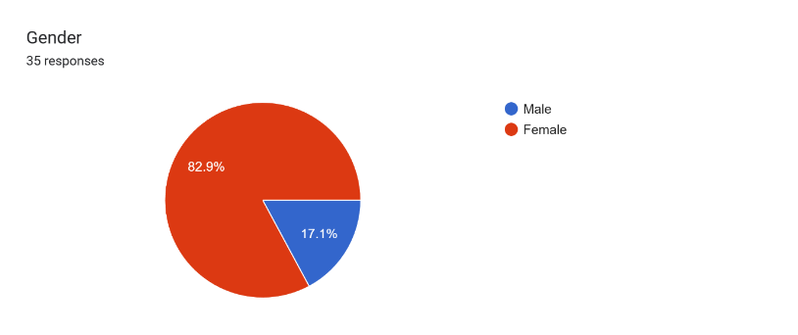

Figure 4: Respondent’s profile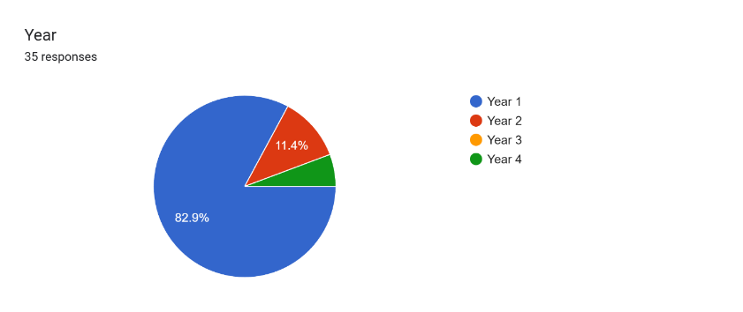

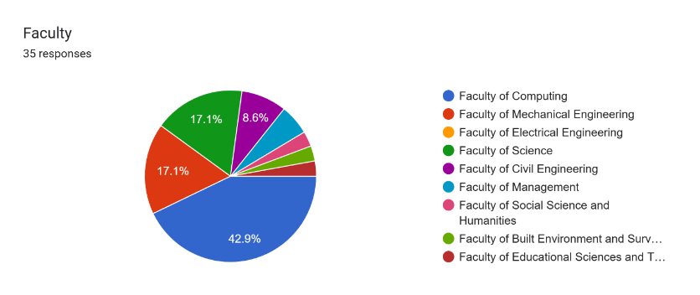

Figure 7

Figure 5: (cont.)

Figure 4 shows that majority of respondents are female and age between 18 to 21 years old. While figure 5 shows that almost all of them are Year 1 students and majority are from Faculty of Computing. Detailed responses of Part B (Awareness of Energy Usage), Part C (Current Behaviour), Part D (Problems Faced), and Part E (Smart Energy Solution - Ideation Support) are documented in Appendix A.

### 4.2.3 Ideate

After understanding the issues faced by students and staff, three (3) meetings were held to brainstorm ideas and solutions dealing with the issues. Through the meetings, the addition of a thermal imaging sensor feature to the product was finally decided. Thermal imaging sensor detects and visualises the heat which is the infrared radiations emitted by human to determine the appropriate time to switch off the electrical appliances in order to reduce energy wastage. Other than that, a product called matric card sensor was also created. It turns on the desktops once the students’ matric cards are inserted.

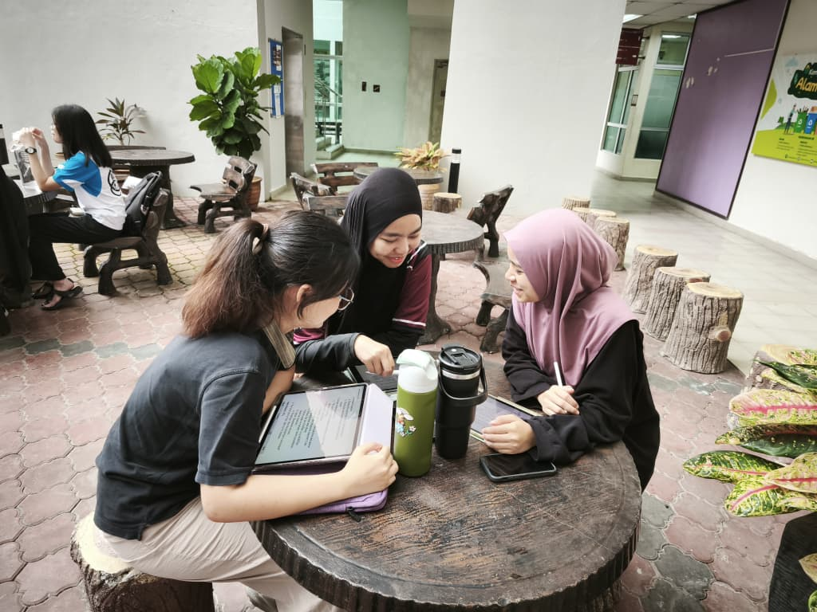

Figure 12: Task Distribution

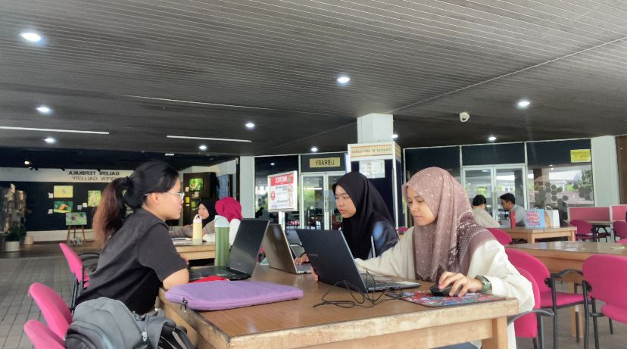

Figure 13: Brainstorm and Report Writing

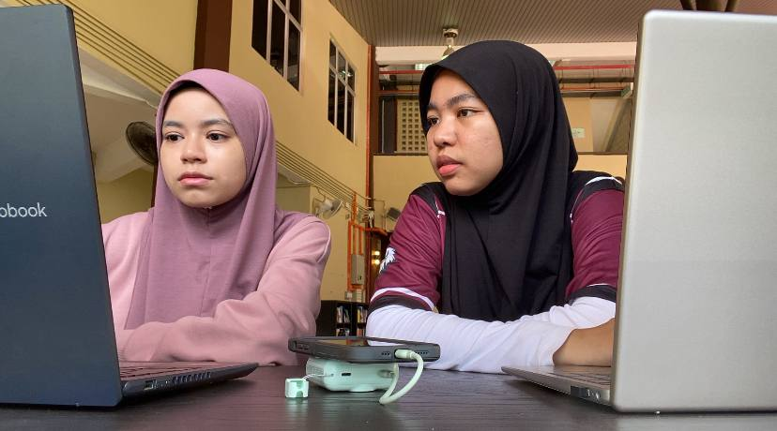

Figure 14: Video Editing

### 4.2.4 Prototype

In prototype phase, all the data, ideas and opinions collected from the previous phases were applied as the guidance for creating the prototype.

**“ThermiQ”**

|  |  |
| --- | --- |
|  | ThermiQ will show “NO” to indicate that no human body temperature is detected. |
|  | ThermiQ will show “YES” to indicate that human body temperature is detected. |
|  | Once human body temperature is detected inside the classrooms, ThermiQ will start to countdown from five to one. |
|  | After countdown, ThermiQ will turn on the electrical appliances such as lights and air-conditioner based on the presence of people in specifics area. Lights and air-conditioner in area D are switched on due to the presence of people. |
|  | Lights and air-conditioner in area A and E are switched on due to the presence of people. |
|  | When no body temperature is detected, ThermiQ will start a two-minute countdown. If no one is detected during this period, lights, air-conditioners and projector is automatically turned off. |

**Matric Card Reader**

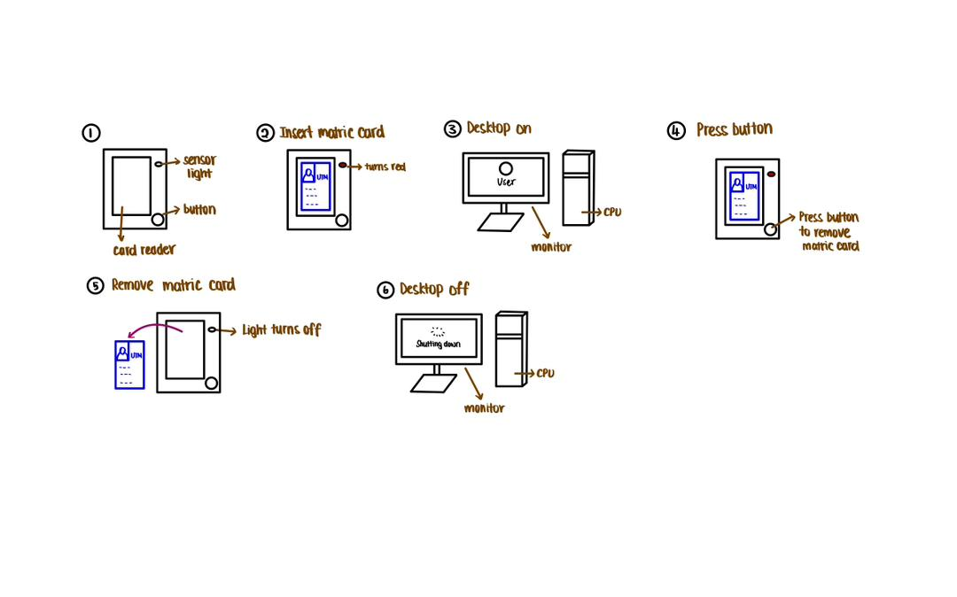

|  |  |
| --- | --- |
| **STEP** | **DESCRIPTION** |
| 1 | The sensor light will turn green to indicate that there is no obstruction and allowing the user to insert their card. |
| 2 | When the card is inserted into the card reader, the sensor light will turn red to notify the user that the card is insert correctly. |
| 3 | The card reader will immediately read and verify the user’s identity. If verify as UTM student, the assigned PC will automatically turn on. |
| 4 | After the user finish using the PC, instead of pulling the card from the reader, they can press the button safely and release the card. |
| 5 | The sensor light will turn back green to indicate that the user’s card has been release correctly without any issues. |
| 6 | When the card is removed, the system will safely log out and turn off the PC automatically. |

### 4.2.5 Testing

During the testing phase of the prototype, two (2) users are invited to try out the products. The prototype received positive feedback, and it was commented that the products are very useful in ensuring energy sustainability and reducing carbon footprints.

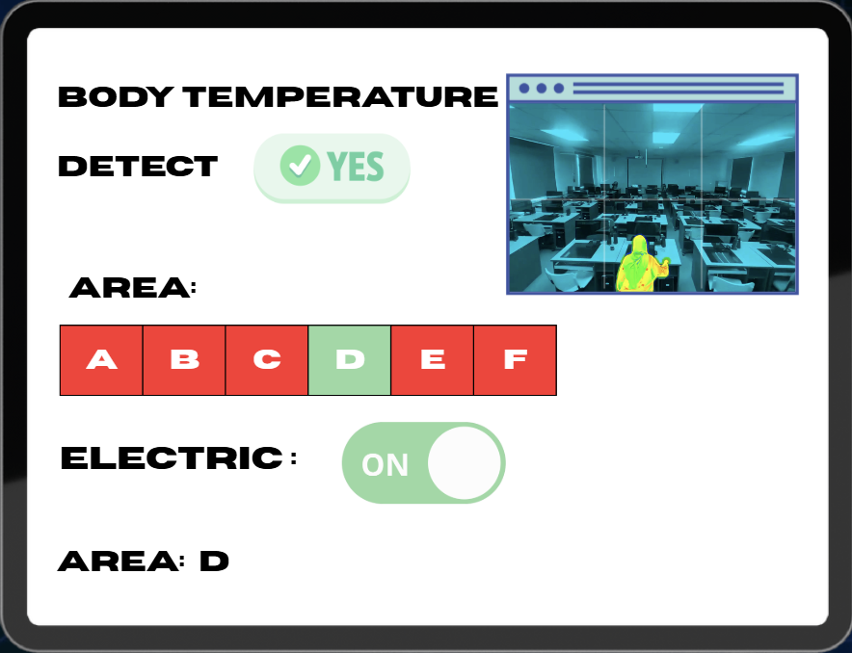

Figure 15: “ThermiQ” Testing

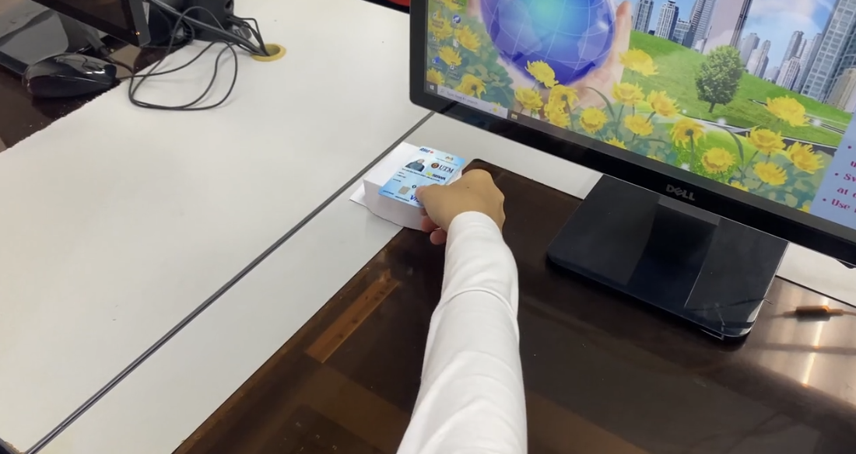

Figure 16: Matric Card Reader Testing

Figure 15 shows that “ThermiQ” will detect body temperature to operate the electrical appliances in a classroom while figure 16 shows the demonstration of matric card reader, where the assigned PC will operate only if matric card is detected. This allows students to see how the product work in a real situation.

# REFLECTIONS

|  |  |
| --- | --- |
| **SHASYA SHAFIEQAH BINTI SHAHARUDDIN (A25CS0350)** | 1. Working with computers has been my dream since I first started learning courses that involved the use of computers in my secondary school, so my goal is to develop my skills and understanding in the field of computing, as I have a strong interest in exploring how computer systems and technologies work. 2. By conducting surveys via Google Forms and interviews with students and staff, I was able to gather real data and understand practical challenges related to energy at our campus. Furthermore, preparing the report and progress video helped me enhanced my computing and analytical skills in a real-world context. This experience supports my goal of developing practical computing skills and understanding how technology can be applied to solve real-life problems. 3. I plan to strengthen both my technical and soft skills. For soft skills, as I know that my communication skills need improvement, I plan to actively involve myself in various activities, such as group projects, workshops, and presentations, to enhance them. Additionally, for my technical skills, I aim to improve in areas like programming and data analysis through courses, practical projects, and internships. By doing so, I hope to be better prepared for a future career and contribute effectively to technological and security advancements. |
| **YONG SEE EN**  **(A25CS0168)** | 1. My goal with regard to my course, which is data engineering is to apply all the techniques and skills I learned throughout my four-year university journey. I aim to become a competent and skilled data engineer who can develop creative and well-structured solutions to solve real-world problems and manage large projects. Hence, I need to build a strong fundamental and deeply understanding all the knowledge gained during the four years of university. 2. This design thinking project helps me gain a deeper understanding of the requirements of users and how to design solutions to solve them. Throughout this project, I learned how to analyse users’ needs, apply critical thinking skills and problem-solving skills to solve a real-world issue. Not only that, since this is a group project, I learned how to communicate with group members to gather and integrate all the ideas to design a functional solution that fulfil the requirements. 3. To improve my potential in the industry, I plan to enhance my technical skills and programming skills such as C++, HTML and Java. A strong foundation on the core academic courses is essential as it acts as a stepping stone in the industry. I need to do continuous research to ensure that I keep up with the latest developments in the fast-paced technology era. Apart from that, soft skills like communication skills, debating skills and presentations skills should be mastered so that I can clearly explain my projects to the company or individuals with insufficient data-related knowledge. Thus, I plan to involve myself into more activities and programmes that able to train my speaking skills. |
| **BALQIS BATRISYA BINTI JALALUDDIN**  **(A25CS0196)** | 1. My goal regarding my course is to gain deeper knowledge and skills that will prepare me for real-world challenges. I want to strengthen my understanding of the concepts that I learn, so that I can apply them confidently in my practical situations. 2. This design thinking project is impacting my goal because it helps me in improving my problem-solving and critical thinking skills, where these skills are really important in industry world. I also get to improve my teamwork, research and prototyping skills, which it is essential for my professional development. 3. In order to improve my potential in the industry, I need to practice applying the design thinking concepts in my projects and assignments during my studies. Other than that, I plan to master all programming skills during my four-year degree journey, as it is a core skill that is very important to computer science students. I also need to continuously developing my technical and soft skills especially communication and teamwork as these skills are highly required in industry. |

# 6.0 TASK DISTRIBUTION

|  |  |  |
| --- | --- | --- |
| **No.** | **Group Members** | **Tasks** |
| 1. | Shasya Shafieqah binti Shaharuddin  A25CS0350 | * Report Writing * Video Editing * Prototype design * Interview Technical Staff |
| 2. | Yong See En  A25CS0168 | * Create Google Form for Survey * Report Writing * Interview Student * Prototype design |
| 3. | Balqis Batrisya binti Jalaluddin  A25CS0196 | * Report Writing * Video Editing * Video Recording |

# 7.0 CONCLUSION

Nowadays, energy wastage has become a common problem especially on campus, as classrooms plays a big role in contributing to energy usage. This project is highlighting that improvement need to be made to reduce higher energy consumption, therefore thermal imaging sensor and matric card reader has been created to support sustainability at campus. Both devices have a great functionality, where thermal imaging sensor can detect occupancy and the exact area in classrooms while matric card reader can save energy by turning on individual electrical equipment only when students put their matric card at the device. To sum up, this approach not only supports sustainability and helps in reducing the campus operational costs, but it also encourages awareness of responsible energy behaviour among campus users.

# 8.0 REFERENCE

RWJ Barnabas Health. (n.d.). *Thermal Imaging Frequently Asked Questions*. doi:https://www.rwjbh.org/rwj-university-hospital-hamilton/patients-visitors/what-you-need-to-know-about-covid-19/thermal-imaging-frequently-asked-questions/

Team Asana . (1 February, 2025). *What is Teamworking?* Retrieved from 11 Benefits of teamwork in the workplace (with examples): https://asana.com/resources/teamwork-in-the-workplace

Universiti Teknologi Malaysia. (n.d.). *Faculties at Universiti Teknologi Malaysia*. Retrieved from Universiti Teknologi Malaysia: https://www.utm.my/about/faculties/

# 9.0 VIDEO

Video link: <https://youtu.be/LfIVa4f8p3s>

# 10.0 APPENDIX

**APPENDIX A**

**4.2.2.2 Responses of Part B**

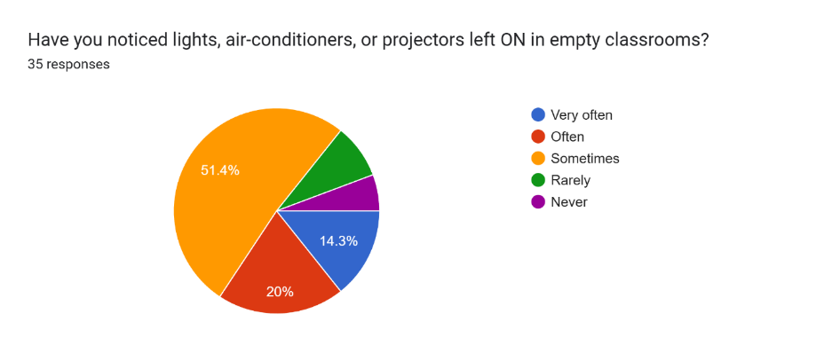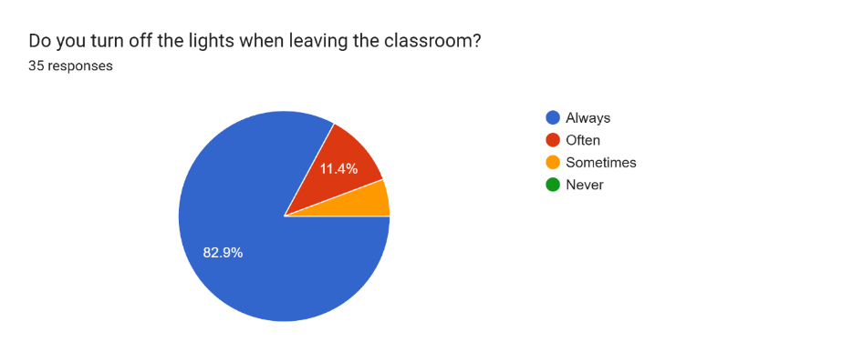

Figure 6: Respondents awareness

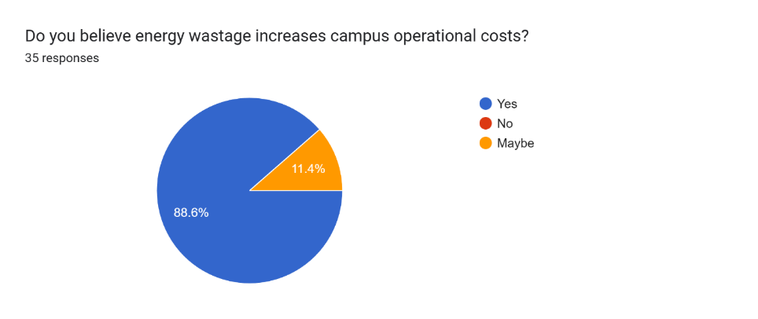

Figure 7: (cont.)

Figure 6 and Figure 7 show the awareness of the respondents on energy. Figure 6 shows 82.9% of respondents always turn off the lights when leaving the classroom while almost 95% noticed the electrical appliances are left ON in empty classrooms. Figure 7 shows almost all of them believe energy wastage increases campus operational costs. The results indicate the respondents demonstrate a high level of awareness regarding energy conservation. However, the high percentage of respondents noticing electrical appliances left switched on in empty classrooms indicates that energy wastage still occurs. Furthermore, a strong agreement that energy wastage increases campus operational costs reflects a clear understanding of the consequences of energy usage and wastage.

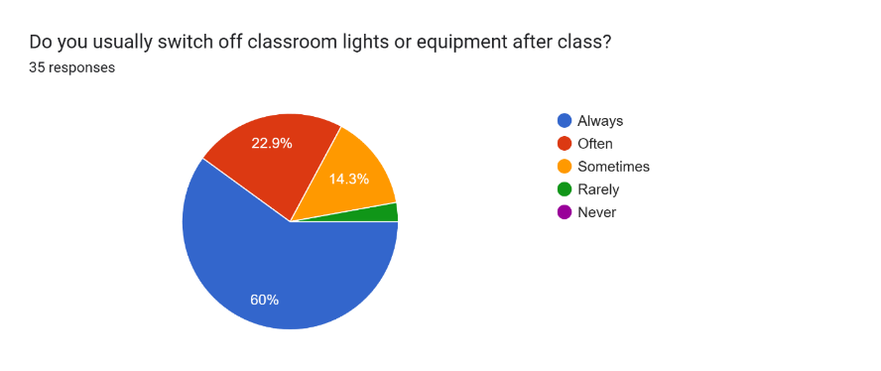**4.2.2.3 Responses of Part C**

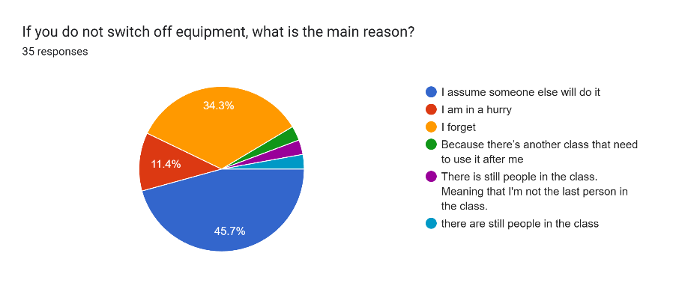

Figure 8: Respondents behaviour

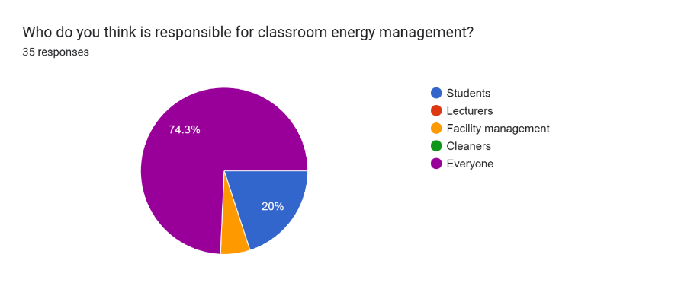

Figure 9: (cont.)

Figure 8 and Figure 9 show the behaviour of the respondents on energy usage. Figure 8 shows almost all of the respondents switch off the electrical appliances after class. For the main reason why they do not switch off equipment, almost 50% assume someone else will do it, 34.3% forget, and 11.4% are in a hurry due to packed timetable. Figure 9 shows almost all of the respondents think that everyone is responsible for classroom energy management. Overall, the findings indicate positive energy-saving behaviour among respondents, but human factors remain a key contributor to energy wastage, even though shared responsibility for energy management is widely acknowledged.

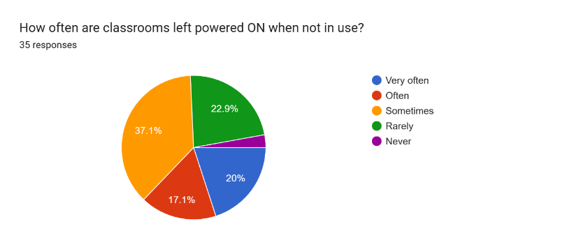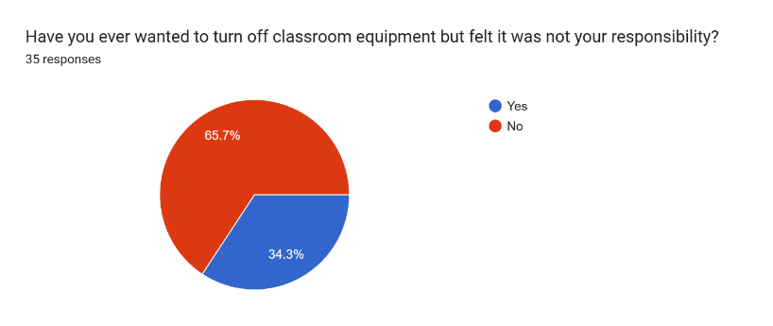**4.2.2.4 Responses of Part D**

Figure 10: Problem faced by respondents

Figure 10 shows that 34.3% of the respondents felt that turning off shared equipment was not their responsibility, and this leads to almost all classrooms are observed to be left powered ON when not in use. This result indicates that responsibility is directly linked to the behaviour. If students don’t feel responsible for switching off equipment, they are less likely to do it.

**4.2.2.5 Responses of Part E**

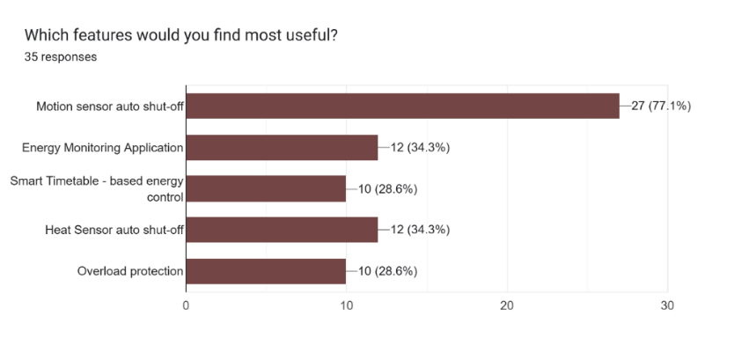

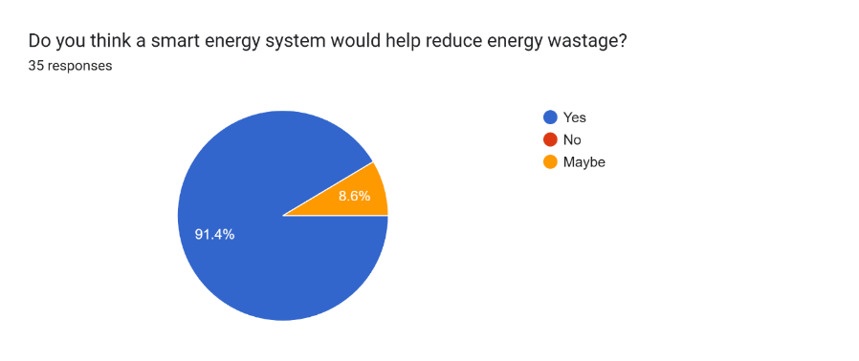

Figure 11: Smart system for improvement

Figure 11 shows that 77.1% of the respondents preferred a motion sensor auto shut-off feature to be added whereas all respondents agree that a smart energy system would help in reducing energy wastage. This indicates students are open to technological solutions that reduce the need for manual effort in turning off equipment.

**APPENDIX B**

**Journey Map**

|  |  |  |  |  |
| --- | --- | --- | --- | --- |
| **Stage** | **Actions** | **Problems** | **Emotions** | **Solutions** |
| Before Class | When enters classroom, lights and air-conditioners already on | Lack awareness of energy usage | Indifferent | Checks classroom condition and turns off unnecessary electrical appliances if low temperature is detected |
| During Class | Use lights, air-conditioners, projector | Uses many unnecessary electrical equipment | Comfortable | - Detects human body temperature and automatically turns on electrical appliances  - Desktops will only being turned on when detects presence of matric card |
| After Class | Rushes to next class | Forget to switch off the electrical appliances | Stressed, nervous | Detects low temperature and automatically turns off unnecessary electrical appliances after class |
| Leaving Classroom | Notices all the equipment remain on | Hesitate if it is their responsibility | Confused, hesitant | No human body temperature is detected, turns off the equipment in 120 seconds |
| End of Day | Reflects on energy usage | Realises energy wastage and increase in carbon footprint | Concerned, guilty | Provide a summary of daily energy usage |